 TROP-2
PATIENT REPORT DATE BOOKING ID
Namita Malhotra 50/F 07 December 2023 # 012311300105

TROP-2 Immunohistochemistry

Test Description

This test is useful for identification of neoplasms expressing

Tumor-associated calcium signal transducer 2.
Trop-2 or Tumor-associated calcium signal transducer 2, also known as epithelial glycoprotein-1 antigen (EGP-1), is a protein that in humans is encoded by the TACSTD2 gene. This transmembrane glycoprotein functions in a variety of cell signaling pathways and was first elucidated as a transducer of an intracellular calcium signal. Trop-2 expression has been demonstrated to depend on a large variety of transcription factors. Trop-2 is involved in several cell signaling pathways, of which many are associated with tumorigenesis.

Specimen
Sample Type: FFPE cell block S.13547.23
Pathology ID: MOLQ IHC-020/23

Interpretation
The scoring system is based on type and origin of tumor. If additional interpretation or analysis is needed, send request for Pathology Consultation.

Methodology
Immunostaining for TROP-2 protein was done using Mouse Anti- Human Monoclonal Antibody (Clone BSB-148).
Positive TROP-2 staining/expression is defined as complete and circumferential or linear plasma membrane staining at any intensity that can be differentiated
from background.

Note
Preclinical studies suggest that Trop-2 may play a role in tumor progression given the involvement in several molecular pathways traditionally associated with cancer development. High Trop-2 antibody expression correlates with poor prognosis in Pancreatic Carcinoma, Hilar Cholangiocarcinoma, Cervical Cancer, Gastric Cancer, and others. Increased Trop-2 antibody expression has been associated with poor overall and disease-free survival outcomes across several solid tumors. Given Trop-2’s expression pattern and associated poor prognostic outcomes, Trop-2 is a rational prognostic marker and a possible therapeutic target.
Microscopy Evaluation

Tumor cell staining for TROP-2-Positive.

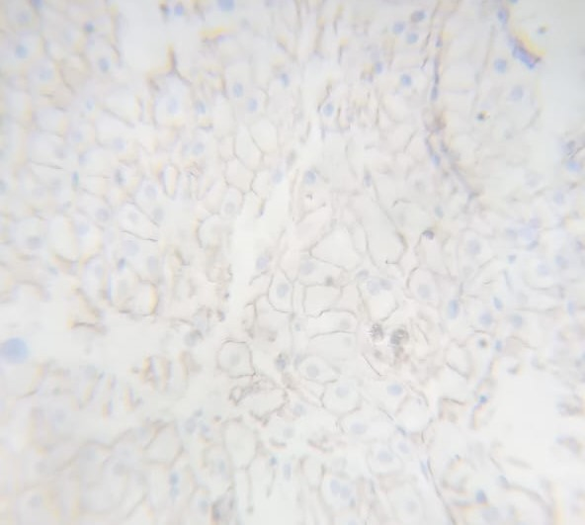

TROP-2 IHC- Tumor Cells

Reviewed By
Dr. Gulshan Yadav, MD,Pathology

TROP-2 Immunostaining- POSITIVE

MolQ Laboratory (A Unit of Molecular Quest Healthcare Pvt. Ltd.)

Reference Laboratory: 28-29, Sector-18 (P) I Gurgaon, Haryana, 122015 I Phone 0124 - 4307906, Fax 0124 - 4278596 I Email: P a g e | 1

