|  |  |  |  |  |
| --- | --- | --- | --- | --- |
| Booking Date | 04/11/2023 | Patient ID 012311040159 | Printed on 18/11/2023 |  |
| Name Ref By | Ms Jeeva  Goswami Diagnostic Centre | Age 18 Days | Sex F |  |

**DIAGNOSIS**: **Normal Karyotype KARYOTYPE:** 46, XX

**INTERPRETATION**: Normal female chromosome. There is no evidence of aneuploidy or structural rearrangement at the resolution of banding analysis.

KARYOTYPE: 46



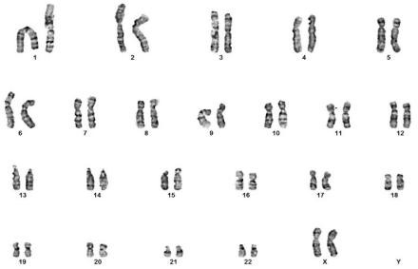

**Peripheral Blood Chromosomal Analysis:**

Please Note: Although the methodology used in this analysis and interpretation is highly accurate, it does not detect small rearrangements and very low-level mosaicism, which are detectable only by molecular methods. Failure to detect an alteration at any locus does not exclude the diagnosis of any of the disorders.

# For test performed on specimens received or collected from non-MolQ locations, it is presumed that the specimen belongs to the patient named or identified as labeled on the container/test request and such verification has been carried out at the point generation of the said specimen by the sender.

MolQ will be responsible only for the analytical part of test carried out. All other responsibility will be of referring Laboratory.