 **TROP-2**

PATIENT REPORT DATE BOOKING ID Mr.Balbir singh kakkar 78/M 16 November 2023 # 01211100072

TROP-2 Immunohistochemistry

## Test Description

This test is useful for identification of neoplasms expressing Tumor-associated calcium signal transducer 2.

|  |
| --- |
| **Microscopy Evaluation** |
| **Tumor cell staining for TROP-2-Positive (2+).** |
|  |

Trop-2 or Tumor-associated calcium signal transducer 2, also known as epithelial glycoprotein-1 antigen (EGP-1), is a protein that in humans is encoded by the TACSTD2 gene. This transmembrane glycoprotein functions in a variety of cell signaling pathways and was first elucidated as a transducer of an intracellular calcium signal. Trop-2 expression has been demonstrated to depend on a large variety of transcription factors. Trop-2 is involved in several cell signaling pathways, of which many are associated with tumorigenesis.

## Specimen

**Sample Type**: FFPE cell block S.14261.23A

**Pathology ID**: MOLQ IHC-017/23

## Interpretation

The scoring system is based on type and origin of tumor. If additional interpretation or analysis is needed, send request for Pathology Consultation.

## Methodology

Immunostaining for TROP-2 protein was done using Mouse Anti- Human Monoclonal Antibody (Clone BSB-148).

Positive TROP-2 staining/expression is defined as complete and circumferential or linear plasma membrane staining at any intensity that can be differentiated

from background.

## Note

Preclinical studies suggest that Trop-2 may play a role in tumor progression given the involvement in several molecular pathways traditionally associated with cancer development. High Trop-2 antibody expression correlates with poor prognosis in Pancreatic Carcinoma, Hilar Cholangiocarcinoma, Cervical Cancer, Gastric Cancer, and others. Increased Trop-2 antibody expression has been associated with poor overall and disease-free survival outcomes across several solid tumors. Given Trop-2’s expression pattern and associated poor prognostic outcomes, Trop-2 is a rational prognostic marker and a possible therapeutic target.

# Reviewed By

Dr. Gulshan Yadav, MD, Pathology

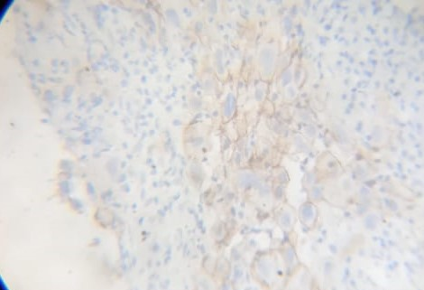

**TROP-2 IHC- Tumor Cells**

**TROP-2 Immunostaining- POSITIVE**

**MolQ Laboratory (A Unit of Molecular Quest Healthcare Pvt. Ltd.)**

Reference Laboratory: 28-29, Sector-18 (P) I Gurgaon, Haryana, 122015 I Phone 0124 - 4307906, Fax 0124 - 4278596 I Email: P a g e | **1**