Patient report

Bio-Rad DATE: 01/27/2023

D-10 TIME: 11:59 AM

S/N: #DC2K755917 Software version: 4.30-2 Sample ID: 11526245

Injection date 01/27/2023 11:42 AM

Injection #: 2 Method: HbA1c

Rack #: --- Rack position: 2

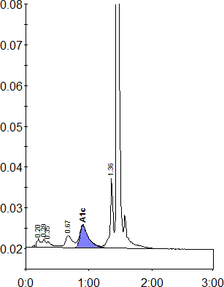

|  |  |  |  |  |  |
| --- | --- | --- | --- | --- | --- |
| Peak table | - | ID: 11526245 | | | |
| Peak | | R.time | Height | Area | Area % |
| A1a | | 0.20 | 2232 | 9255 | 1.3 |
| A1b | | 0.29 | 2105 | 6883 | 0.9 |
| Unknown | | 0.35 | 1467 | 9103 | 1.3 |
| LA1c/CHb-1 | | 0.67 | 3040 | 22829 | 3.1 |
| A1c | | 0.90 | 5495 | 53644 | 9.9 |
| P3 | | 1.36 | 17187 | 53888 | 7.4 |
| A0 | | 1.44 | 230688 | 571149 | 78.6 |
| Total Area: | | 1026750 |  |  |  |

|  |  |
| --- | --- |
| Concentration: | % |
| A1c | 9.9 |