|  |  |  |  |
| --- | --- | --- | --- |
| **Booking Date** | 10/01/2019 | **Patient ID** 011901100288 | **Printed on** 21/01/2019 |
| **Name** | Mr JITENDRA | **Age** 32 Years | **Sex** M |
| **Ref By** | Bhardwaj Clinic |  |  |

**DIAGNOSIS**: Normal Male Karyotype

**KARYOTYPE:** 46, XY

**INTERPRETATION**: Normal male chromosome complement. There is no evidence of aneuploidy or structural rearrangement at the resolution of banding analysis.

**KARYOTYPE: 46, Normal Sex Chromosomes**

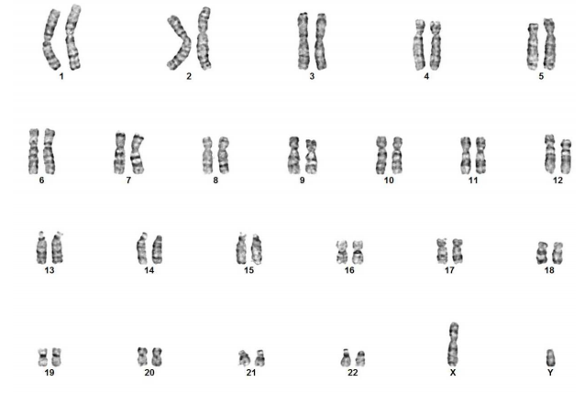

**Peripheral Blood Chromosomal Analysis:**

Please Note: Although the methodology used in this analysis and interpretation is highly accurate, it does not detect small rearrangements and very low-level mosaicism, which are detectable only by molecular methods. Failure to detect an alteration at any locus does not exclude the diagnosis of any of the disorders.