|  |  |  |  |
| --- | --- | --- | --- |
| Booking Date | 26/07/2016 | Patient ID 011607260229 | Printed on 10/08/2016 |
| Name | B/o Jyoti | Age 40 Days | Sex F |
| Ref By | S.P.G.Diagnostics,Agra |  |  |

**DIAGNOSIS**: Normal Female Karyotype

**KARYOTYPE:** 46, XX

**INTERPRETATION**: Normal female chromosome complement. There is no evidence of aneuploidy or structural rearrangement at the resolution of banding analysis.

**KARYOTYPE: 46, Normal Sex Chromosomes**

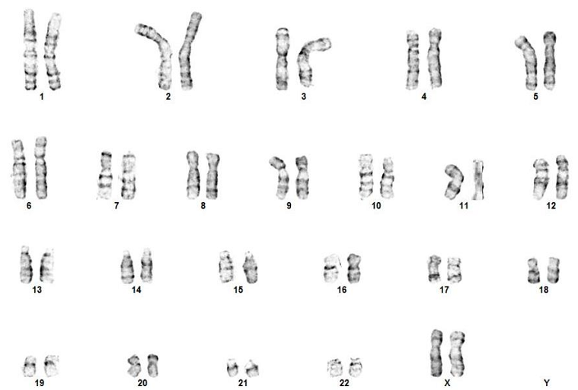

**Peripheral Blood Chromosomal Analysis:**

Please Note: Although the methodology used in this analysis and interpretation is highly accurate, it does not detect small rearrangements and very low-level mosaicism, which are detectable only by molecular methods. Failure to detect an alteration at any locus does not exclude the diagnosis of any of the disorders.